 | Full (Ref)  N=7,019 | Marginal  N=1,136 | Low  N=1,218 | Very Low  N=721 | Overall  (N=10,094)
 | N (%) | N (%) | N (%) | N (%) | N (%)
Sex
Male | 3509 (50) | 533 (46.9) | 569 (51.5) | 569 (46.7) | 4,954 (49.1)
Female | 3,510 (50.0) | 603 (53.1) | 649 (53.3) | 378 (52.4) | 5,140 (50.9)
Age (years) | 49 (19) | 42 (18) | 42 (17) | 42 (16) | 47 (19)
Race/Ethnicity
NH White | 3,412 (48.6) | 345 (30.4) | 318 (26.1) | 250 (34.7) | 4,325 (42.8)
NH Black | 1,441 (20.5) | 297 (26.1) | 331 (27.2) | 194 (26.9) | 2,263 (22.4)
Mexican-American | 868 (12.4) | 267 (23.5) | 294 (24.1) | 139 (19.3) | 1,568 (15.5)
Other Hispanic | 520 (7.4) | 126 (11.1) | 165 (13.5) | 95 (13.2) | 906 (9.0)
Other, incl. Multi-Racial | 778 (11.1) | 101 (8.9) | 110 (9.0) | 43 (6.0) | 1,032 (10.3)
Highest Educational Attainment
Less than 9th Grade | 1,382 (19.7) | 396 (34.9) | 504 (41.4) | 284 (39.4) | 2,566 (25.4)
High School Graduate or Equivalent | 1,730 (24.6) | 320 (28.2) | 327 (26.8) | 197 (27.3) | 2,574 (25.5)
Some College | 1,939 (27.6) | 313 (27.6) | 303 (24.9) | 210 (29.1) | 2,756 (27.4)
College or Above | 1,968 (28.0) | 107 (9.4) | 84 (6.9) | 30 (4.2) | 2,189 (21.7)
Poverty Income Ratio
Low Poverty | 993 (14.1%) | 397 (34.9%) | 528 (43.3%) | 375 (52.0%) | 2,293 (22.7%)
Near Poverty | 1,560 (22.2%) | 405 (35.7%) | 458 (37.6%) | 262 (36.3%) | 2,685 (26.6%)
Middle Income | 1,085 (15.5%) | 178 (15.7%) | 127 (10.4%) | 53 (7.4%) | 1,443 (14.3%)
Upper-Middle Income | 1,679 (23.9%) | 124 (10.9%) | 91 (7.5%) | 27 (3.7%) | 1,921 (19.0%)
High Income | 1,702 (24.2%) | 32 (2.8%) | 14 (1.1%) | 4 (0.6%) | 1,752 (17.4%)
Cycle Year
2005–2006 | 1,179 (16.8) | 154 (13.6) | 148 (12.2) | 70 (9.7) | 1,551 (15.4)
2007–2008 | 1,313 (18.7) | 175 (15.4) | 168 (13.8) | 93 (12.9) | 1,749 (17.3)
2009–2010 | 1,246 (17.8) | 197 (17.3) | 234 (19.2) | 148 (20.5) | 1,825 (18.1)
2011–2012 | 1,109 (15.8) | 195 (17.2) | 192 (15.8) | 127 (17.6) | 1,623 (16.1)
2013–2014 | 1,203 (17.1) | 199 (17.5) | 218 (17.9) | 138 (19.1) | 1,758 (17.4)
2015–2016 | 969 (13.8) | 216 (19.0) | 258 (21.2) | 145 (20.1) | 1,588 (15.7)

Table 1: Unweighted Demographic Characteristics of the Analytic Study Population
- Unweighted descriptive statistics count (frequency) and proportion (percentage) per food security category reported.
Table 2: Detection Frequency and Distribution of Urinary Phenol Concentrations (ng/mL)

Urinary Metabolite | Abbreviation | %>LOD | 25th | GM | 75th
Bisphenol A | BPA | 92% | 0.69 | 1.52 | 3.10
2-Hydroxy-4-metoxybenzophenone | Benzophenone-3 | 96% | 4.71 | 21.05 | 76.71
2,4,4’-Trichloro-2’-hydroxyphenyl ether | Triclosan | 75% | 1.80 | 12.22 | 49.40
Ethyl paraben | EPB | 50% | 0.71 | 2.51 | 6.70
Methyl paraben | MPB | 99% | 13.33 | 51.21 | 192.50
Propyl paraben | PPB | 95% | 1.11 | 6.72 | 40.90
- %>LOD represents the limit of detection of phenol metabolite concentrations. Values below the detection limit are imputed as LOD $\sqrt{2}$by NHANES. The 25th and 75th percentiles are log-transformed. GM represents the geometric mean.

Table 3: Adjusted Linear Regression: Self-Reported Food Security Status and Urinary Phenol Metabolites

Phenol Metabolite | Food Security Level | % Difference | 95% CI
BPA | High (Ref)
 | Marginal | 1.80 | -5.91 | 10.15
 | Low | 7.53 | -1.27 | 17.12
 | Very Low | 7.61 | -4.48 | 21.23
BP3 | High (Ref)
 | Marginal | -19.82 | -31.68 | -5.91
 | Low | -17.40 | -29.05 | -3.84
 | Very Low | -19.55 | -35.27 | -0.02
TRS | High (Ref)
 | Marginal | -14.72 | -28.86 | 2.22
 | Low | -12.65 | -25.06 | 1.80
 | Very Low | -24.46 | -36.76 | -9.77
$$EPB$$ | High (Ref)
 | Marginal | -10.97 | -21.90 | 1.50
 | Low | -5.65 | -17.98 | 8.53
 | Very Low | -25.96 | -35.07 | -15.57
$$MPB$$ | High (Ref)
 | Marginal | -16.65 | -26.78 | -5.10
 | Low | -14.81 | -28.35 | 1.29
 | Very Low | -21.53 | -35.05 | -5.18
$$PPB$$ | High (Ref)
 | Marginal | -16.26 | -28.75 | -1.59
 | Low | -15.16 | -32.01 | 5.85
 | Very Low | -25.08 | -40.79 | -5.20
- Values are adjusted percent differences in urinary phenol metabolite concentrations (ng/mL) compared to the High Food Secure category (reference group) based on multivariable linear regression models. adjusted for age, gender, education, cycle year, race/ethnicity, poverty: income ratio and creatinine.
- 95% LCI= 95% lower confidence interval; 95% UCI= 95% upper confidence interval.
- Abbreviations: BPA =Bisphenol A; BP3 =Bbenzophenone-3; TRS = 2,4,4’-Trichloro-2’-hydroxyphenyl ether; EPB = ethyl paraben; MPB = methyl paraben; PPB = propyl paraben.

Figure 1: Household Food Security Associations with Urinary Phenol Concentrations
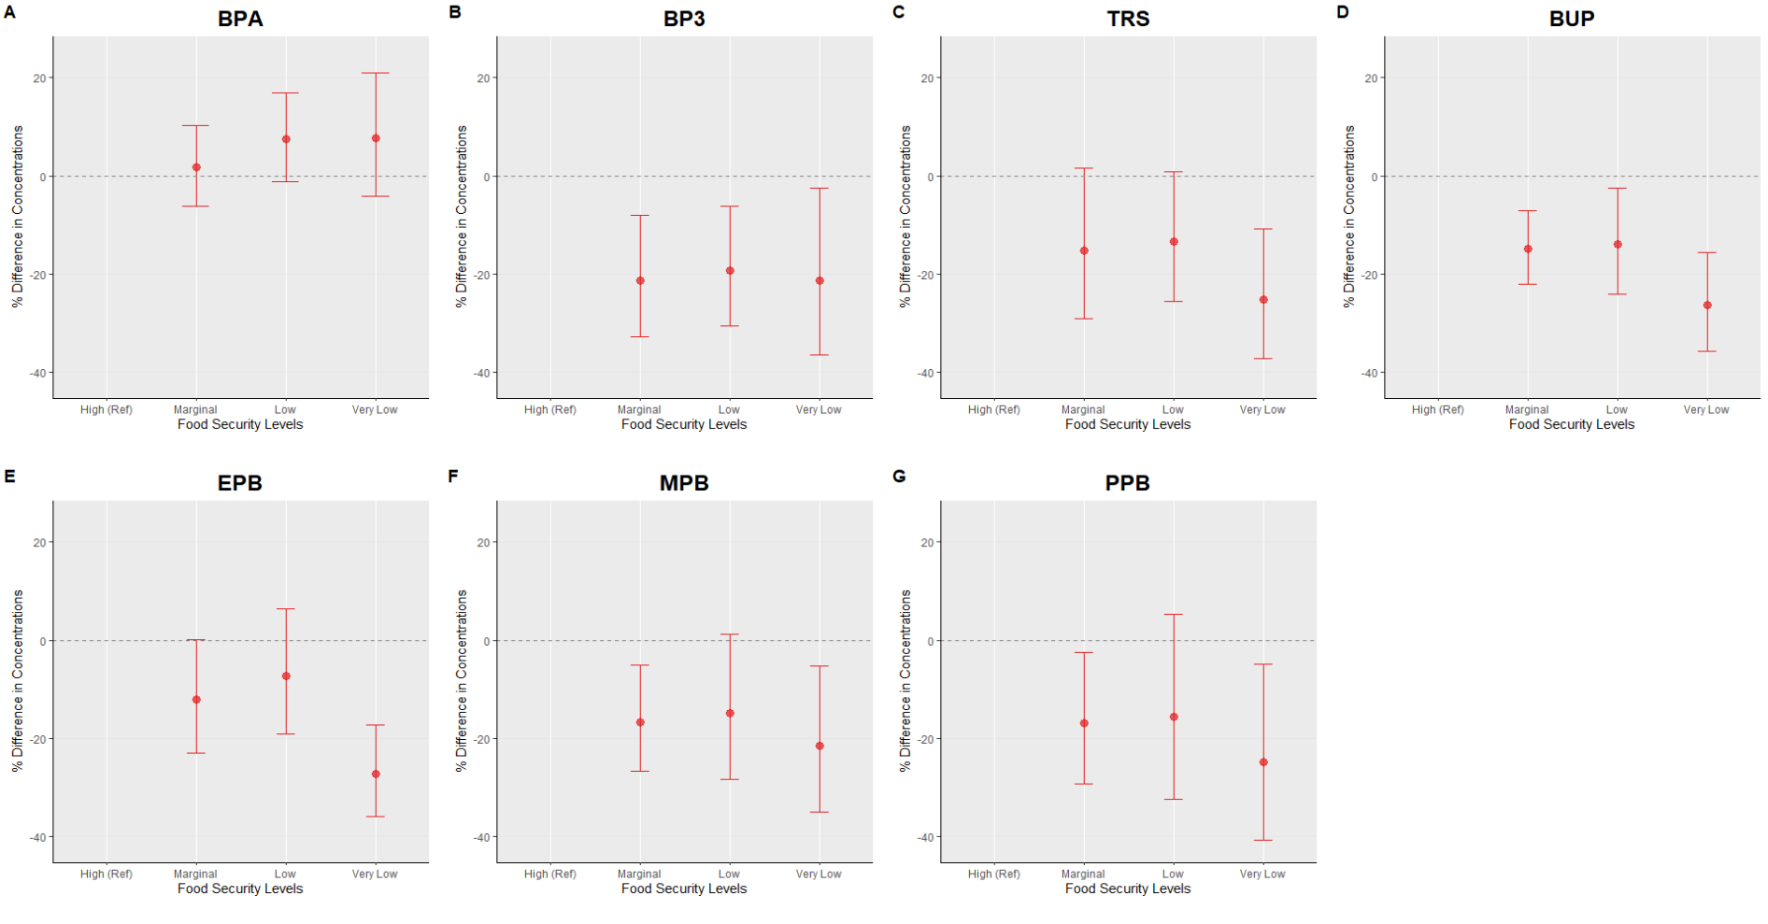
- Panels A–G represent adjusted percent differences in urinary phenol metabolite concentrations. Reference is High Food Secure. Circles represent estimated percent differences; bars represent 95% confidence intervals. All models are adjusted for age, sex education, race/ethnicity, poverty-income ratio, cycle year, and creatinine.

Figure 2: Strata Specific Adjusted Linear Regression Plot: Self-Reported Food Security Status and Urinary Phenol Metabolites with Sex Interaction

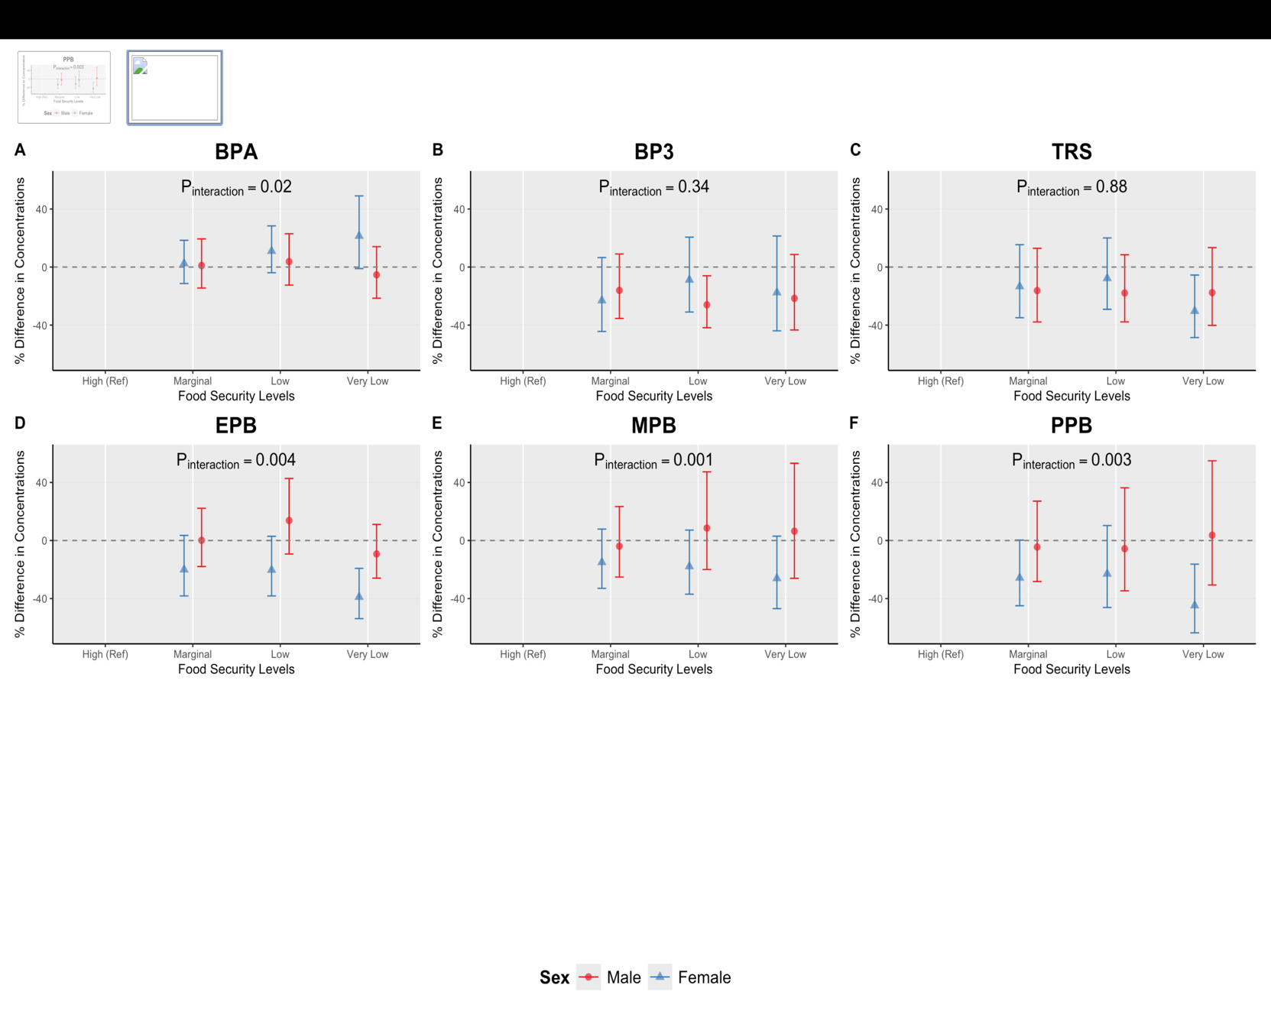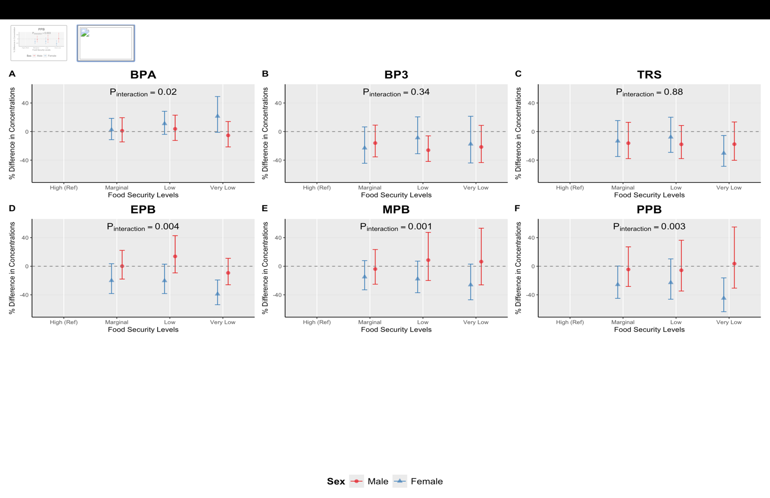
- Sex stratified adjusted percent differences (95% confidence intervals) in urinary phenol metabolite
- Concentrations across food security levels, estmated from multivariable linear regression models adjusted for age, race and ethnicity, education, survey cycle, poverty:income ratio and creatinine. High Food Secure is the reference group.
- P_{interaction} values are reported from food security*sex interaction models, where food security is modeled as continuous variable.

Figure 3: Strata-Specific Adjusted Linear Regression Plot: Self-Reported Food Security Status and Urinary Phenol Metabolites with Race and Ethnicity Interaction
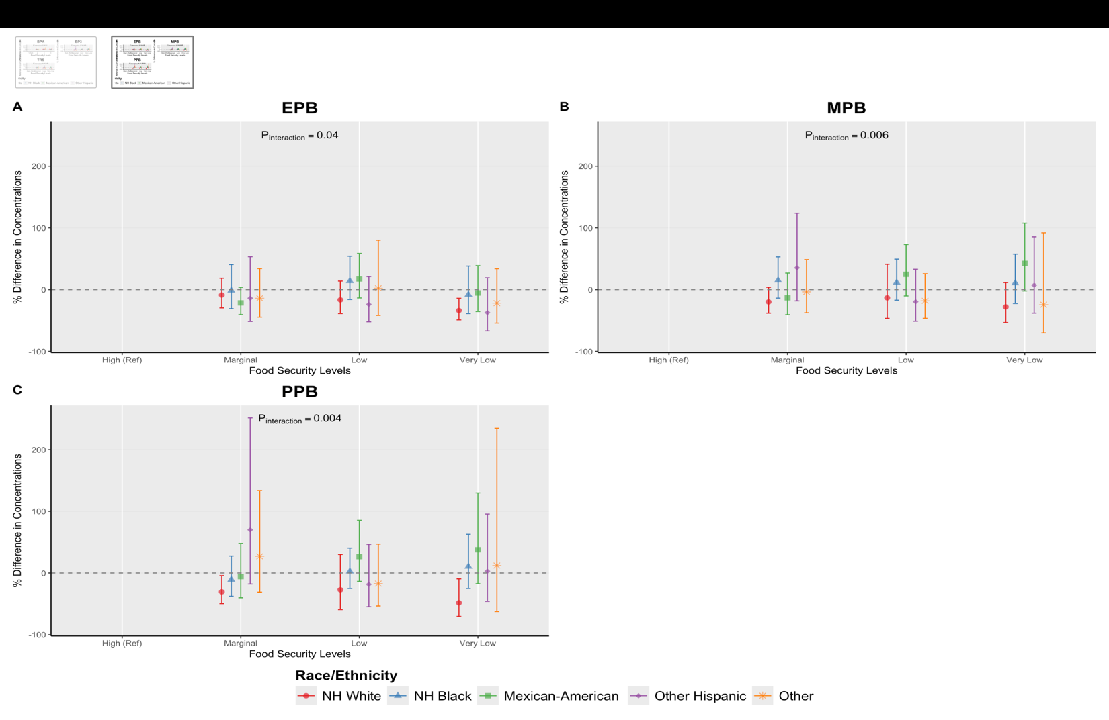

- Race stratified adjusted percent differences (95% confidence intervals) in urinary phenol metabolite concentrations across food security levels, estmated from multivariable linear regression models adjusted for age, sex, education, survey cycle, poverty:income ratio and creatinine. High Food Secure is the reference group.
- P_{interaction} values are reported from food security*race and ethnicity interaction models, where food security is modeled as continuous variable.
- NH White: Non Hispanic White; NH Black: Non-Hispanic Black

Supplemental Figure 1: Flowchart for NHANES Analytic Sample (2005-2016)
16,349 NHANES participants with available phenols, food security and/or demographic data
Removed 4,870 pediatric patients
(<18 years)

11,479 Adult participants with phenols measured across relevant cycle years 2003-2016

Removed 1,056 participants with missing creatinine, or food security data

10,423 Adult participants with available creatinine and USDA FSSM questionnaire data

Excluded 329 participants missing urinary phenol concentration data

10,094 included in final analytic cohort (complete cases)

- Adult participants from the 2005–2016 NHANES cycles were included if demographic, food security, urinary Phenol, and urinary creatinine data were available. Participants were excluded for missing exposure values, missing urinary creatinine or urinary Phenol concentrations, and extreme outliers.
- Abbreviations: NHANES, National Health and Nutrition Examination Survey; FSSM, Food Security Survey Module; SD, standard deviation

Supplemental Figure 2: Spearman Correlation Matrix for Log Urinary Phenol Metabolites

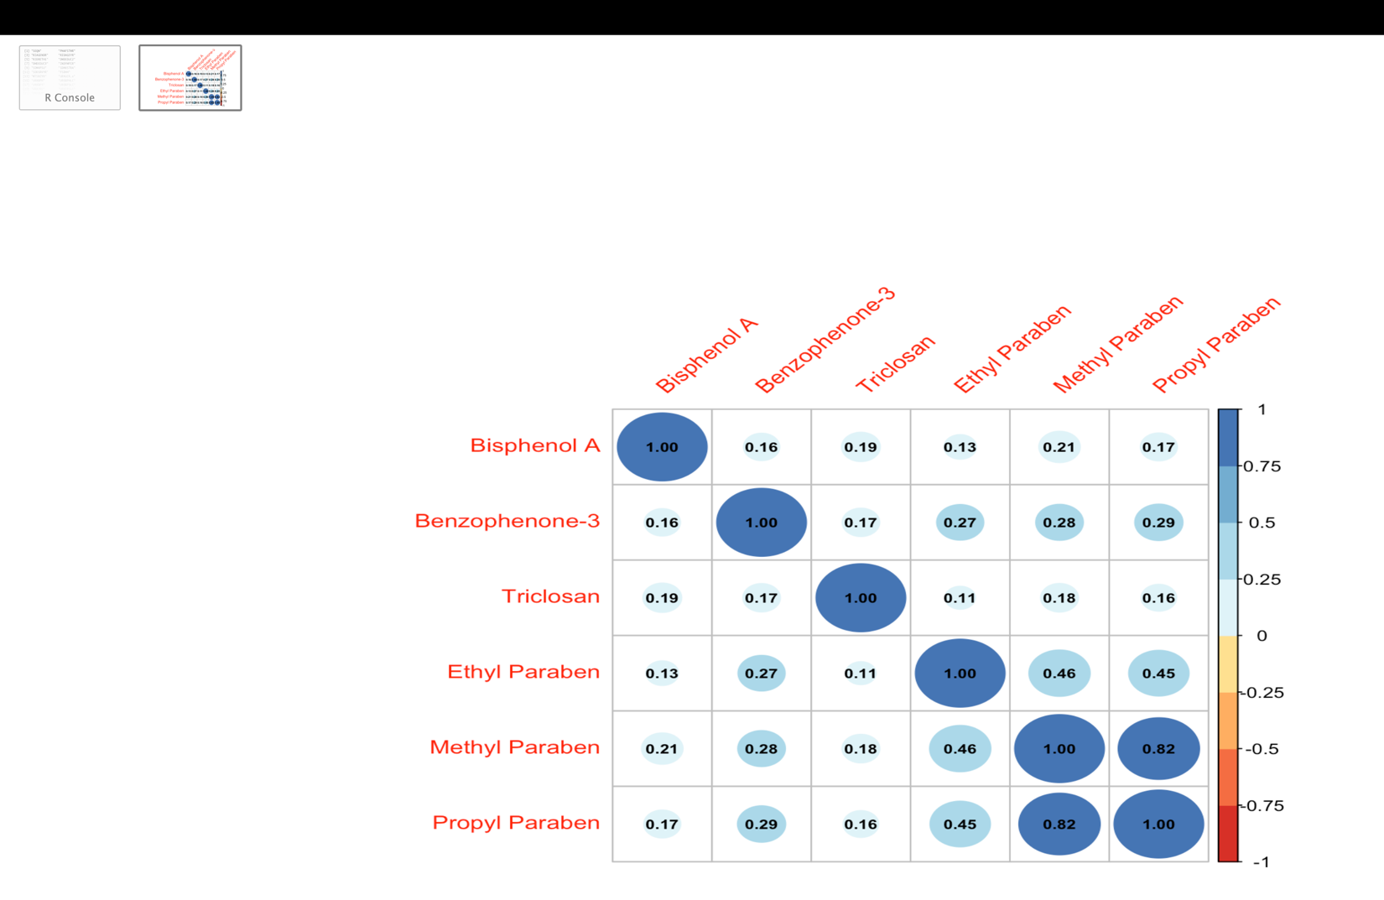

- Spearman correlation coefficients are visualized, with larger and darker circles indicating stronger positive correlations between analytes. All correlations shown are positive, suggesting co-occurrence or shared sources among the measured phenol metabolites and related compounds.

Supplemental Table 1: Creatinine Adjusted: Self-Reported Food Security Status
O  Phenol Metabolite del | Term | % Difference | 95% CI
BPA | High (Ref)
 | Marginal | 1.36 | -11.93 | 16.66
 | Low | -9.85 | -19.51 | 0.97
 | Very Low | -7.25 | -20.00 | 7.53
BP3 | High (Ref)
 | Marginal | -5.08 | -12.02 | 2.41
 | Low | -2.70 | -9.25 | 4.32
 | Very Low | 10.42 | -0.79 | 22.89
TRS | High (Ref)
 | Marginal | 23.17 | 10.38 | 37.43
 | Low | 18.18 | 7.75 | 29.61
 | Very Low | 27.84 | 15.56 | 41.41
EPB | High (Ref)
 | Marginal | -9.56 | -16.70 | -1.82
 | Low | -17.65 | -24.29 | -10.43
 | Very Low | -9.17 | -19.26 | 2.18
MPB | High (Ref)
 | Marginal | 1.61 | -10.47 | 15.31
 | Low | -6.53 | -15.22 | 3.05
 | Very Low | -1.07 | -12.16 | 11.42
PPB | High (Ref)
 | Marginal | 2.86 | -3.72 | 9.89
 | Low | 6.08 | 0.09 | 12.43
 | Very Low | 20.60 | 9.99 | 32.23
- Values are unadjusted percent differences in urinary phenol metabolite concentrations (ng/mL) compared to the reference group (High (Ref)y Food Secure) based on multivariable linear regression models.
- 95% CI= 95% confidence interval.

Supplemental Table 2: Strata Specific Adjusted Linear Regression Full Table: Self-Reported Food Security Status and Urinary Phenol Metabolites with Sex Interaction
Sex | Phenol Metabolite | Food Security Level | % Difference | 95% CI
Male | BPA | High (Ref)
 |  | Marginal | 1.08 | -14.46 | 19.43
 |  | Low | 3.76 | -12.46 | 22.99
 |  | Very Low | -5.35 | -21.46 | 14.06
Female |  | High (Ref)
 |  | Marginal | 2.5 | -11.32 | 18.47
 |  | Low | 11.08 | -3.9 | 28.41
 |  | Very Low | 21.45 | -1.04 | 49.05
Male | BP3 | High (Ref)
 |  | Marginal | -16.08 | -35.4 | 9.02
 |  | Low | -26.04 | -41.81 | -5.99
 |  | Very Low | -21.55 | -43.36 | 8.66
Female |  | High (Ref)
 |  | Marginal | -23.03 | -44.39 | 6.54
 |  | Low | -8.78 | -31 | 20.6
 |  | Very Low | -17.51 | -43.95 | 21.41
Male | TRS | High (Ref)
 |  | Marginal | -16.23 | -37.84 | 12.91
 |  | Low | -17.87 | -37.81 | 8.47
 |  | Very Low | -17.63 | -40.19 | 13.44
Female |  | High (Ref)
 |  | Marginal | -13.31 | -34.9 | 15.43
 |  | Low | -7.74 | -29.12 | 20.09
 |  | Very Low | -30.31 | -48.6 | -5.52
Male | $$EPB$$ | High (Ref)
 |  | Marginal | 0.12 | -17.97 | 22.2
 |  | Low | 13.78 | -9.33 | 42.78
 |  | Very Low | -9.31 | -25.94 | 11.07
Female |  | High (Ref)
 |  | Marginal | -20.04 | -38.24 | 3.51
 |  | Low | -20.29 | -38.25 | 2.89
 |  | Very Low | -38.94 | -53.86 | -19.21
Male | $$MPB$$ | High (Ref)
 |  | Marginal | -3.93 | -25.21 | 23.42
 |  | Low | 8.59 | -19.99 | 47.37
 |  | Very Low | 6.41 | -26.1 | 53.22
Female |  | High (Ref)
 |  | Marginal | -14.99 | -33.01 | 7.87
 |  | Low | -17.85 | -37.03 | 7.18
 |  | Very Low | -26.1 | -46.97 | 2.98
Male | $$PPB$$ | High (Ref)
 |  | Marginal | -4.53 | -28.3 | 27.13
 |  | Low | -5.65 | -34.7 | 36.34
 |  | Very Low | 3.64 | -30.68 | 54.94
Female |  | High (Ref)
 |  | Marginal | -25.71 | -44.96 | 0.27
 |  | Low | -22.96 | -46.2 | 10.31
 |  | Very Low | -44.82 | -63.63 | -16.28

Supplemental Table 3: Strata Specific Adjusted Linear Regression Full Table: Self-Reported Food Security Status and Urinary Bisphenol A Phenol Metabolites with Race and Ethnicity Interaction

Race/Ethnicity Category | Model | Food Security Level | % Difference | 95% CI
NH White | BPA | High (Ref)
 |  | Marginal | 7.19 |  | -9.91 | 27.53
 |  | Low | 9.41 |  | -8.42 | 30.71
 |  | Very Low | 13.96 |  | -11.85 | 47.32
NH Black |  | High (Ref)
 |  | Marginal | -5.26 |  | -18.24 | 9.77
 |  | Low | 1.08 |  | -13.76 | 18.47
 |  | Very Low | -0.25 |  | -15.08 | 17.17
Mexican-American |  | High (Ref)
 |  | Marginal | -4.11 |  | -22.52 | 18.67
 |  | Low | 0.14 |  | -14.43 | 17.20
 |  | Very Low | -11.54 |  | -37.31 | 24.84
Other Hispanic |  | High (Ref)
 |  | Marginal | -5.61 |  | -28.16 | 24.01
 |  | Low | -5.23 |  | -24.30 | 18.65
 |  | Very Low | 2.56 |  | -31.39 | 53.32
Other |  | High (Ref)
 |  | Marginal | -6.79 |  | -31.10 | 26.10
 |  | Low | 36.95 |  | -16.26 | 123.98
 |  | Very Low | 26.41 |  | -18.81 | 96.82
- Values represent percent differences for Food Security Level × Race and Ethnicity interaction terms, showing strata-specific estimates. Within each race and ethnicity group (NH White, NH Black, Mexican American, Other Hispanic, Other, ) estimates indicate the percent difference for each food security level compared with the reference. Estimates are derived from multivariable linear regression models adjusted for age, sex, education, cycle year, poverty: income ratio and creatinine.
- NH White: Non Hispanic White; NH Black: Non-Hispanic Black
- 95% CI = 95% confidence interval

Supplemental Table 4: Strata Specific Adjusted Linear Regression Full Table: Self-Reported Food Security Status and Urinary Benzophenone-3 Phenol Metabolites with Race and Ethnicity Interaction

Race/Ethnicity Category | Model | Food Security Level | % Difference | 95% CI
NH White | BP3 | High (Ref)
 |  | Marginal | -28.70 | -48.72 | -0.87
 |  | Low | -27.92 | -48.98 | 1.84
 |  | Very Low | -33.44 | -58.81 | 7.56
NH Black |  | High (Ref)
 |  | Marginal | -15.93 | -41.65 | 21.12
 |  | Low | -2.98 | -31.62 | 37.65
 |  | Very Low | 11.06 | -27.60 | 70.36
Mexican-American |  | High (Ref)
 |  | Marginal | -2.94 | -36.16 | 47.57
 |  | Low | 1.00 | -27.35 | 40.41
 |  | Very Low | 3.52 | -38.55 | 74.39
Other Hispanic |  | High (Ref)
 |  | Marginal | 45.85 | -24.66 | 182.35
 |  | Low | 2.52 | -37.93 | 69.31
 |  | Very Low | -9.51 | -53.73 | 76.98
Other |  | High (Ref)
 |  | Marginal | -33.54 | -59.54 | 9.16
 |  | Low | -21.54 | -54.22 | 34.48
 |  | Very Low | -5.03 | -56.58 | 107.74
- Values represent percent differences for Food Security Level × Race and Ethnicity interaction terms, showing strata-specific estimates. Within each race and ethnicity group (NH White, NH Black, Mexican American, Other Hispanic, Other) estimates indicate the percent difference for each food security level compared with the reference. Estimates are derived from multivariable linear regression models adjusted for age, sex, education, cycle year, poverty: income ratio and creatinine.
- NH White: Non Hispanic White; NH Black: Non-Hispanic Black
- 95% CI = 95% confidence interval

Supplemental Table 5: Strata Specific Adjusted Linear Regression Full Table: Self-Reported Food Security Status and Urinary Triclosan Phenol Metabolites with Race and Ethnicity Interaction

Race/Ethnicity Category | Model | Food Security Level | % Difference | 95% CI
NH White | TRS | High (Ref)
 |  | Marginal | -19.32 | -44.37 | 17.01
 |  | Low | -21.28 | -42.74 | 8.23
 |  | Very Low | -27.72 | -49.16 | 2.77
NH Black |  | High (Ref)
 |  | Marginal | 3.33 | -31.26 | 55.33
 |  | Low | -4.87 | -31.91 | 32.92
 |  | Very Low | -8.95 | -38.66 | 35.15
Mexican-American |  | High (Ref)
 |  | Marginal | -10.47 | -41.78 | 37.67
 |  | Low | 8.20 | -34.34 | 78.30
 |  | Very Low | -0.75 | -47.93 | 89.18
Other Hispanic |  | High (Ref)
 |  | Marginal | -12.86 | -57.72 | 79.59
 |  | Low | 8.17 | -50.51 | 136.40
 |  | Very Low | -25.50 | -58.93 | 35.15
Other |  | High (Ref)
 |  | Marginal | -15.42 | -55.96 | 62.43
 |  | Low | -28.70 | -61.22 | 31.08
 |  | Very Low | -60.86 | -83.14 | -9.11
- Values represent percent differences for Food Security Level × Race and Ethnicity interaction terms, showing strata-specific estimates. Within each race and ethnicity group (NH White, NH Black, Mexican American, Other Hispanic, Other,) estimates indicate the percent difference for each food security level compared with the reference. Estimates are derived from multivariable linear regression models adjusted for age, sex, education, cycle year, poverty: income ratio and creatinine.
- NH White: Non Hispanic White; NH Black: Non-Hispanic Black
- 95% CI = 95% confidence interval

Supplemental Table 6: Strata Specific Adjusted Linear Regression Full Table: Self-Reported Food Security Status and Urinary Butyl Paraben Metabolites with Race and Ethnicity Interaction

Race/Ethnicity Category | Model | Food Security Level | % Difference | 95% CI
NH White | BUP | High (Ref)
 |  | Marginal | -23.95 | -37.16 | -7.96
 |  | Low | -22.47 | -37.52 | -3.79
 |  | Very Low | -32.29 | -48.42 | -11.10
NH Black |  | High (Ref)
 |  | Marginal | -5.33 | -27.71 | 23.98
 |  | Low | -3.31 | -30.20 | 33.93
 |  | Very Low | -20.74 | -40.46 | 5.51
Mexican-American |  | High (Ref)
 |  | Marginal | -1.61 | -31.75 | 41.85
 |  | Low | 25.63 | -10.42 | 76.19
 |  | Very Low | -1.23 | -30.43 | 40.24
Other Hispanic |  | High (Ref)
 |  | Marginal | 11.36 | -40.68 | 109.06
 |  | Low | -24.56 | -49.68 | 13.09
 |  | Very Low | -31.89 | -55.71 | 4.73
Other |  | High (Ref)
 |  | Marginal | 7.27 | -36.14 | 80.19
 |  | Low | -14.83 | -42.98 | 27.20
 |  | Very Low | 5.63 | -49.97 | 123.05
- Values represent percent differences for Food Security Level × Race and Ethnicity interaction terms, showing strata-specific estimates. Within each race and ethnicity group (NH White, NH Black, Mexican American, Other Hispanic, Other,) estimates indicate the percent difference for each food security level compared with the reference. Estimates are derived from multivariable linear regression models adjusted for age, sex, education, cycle year, poverty: income ratio and creatinine.
- NH White: Non Hispanic White; NH Black: Non-Hispanic Black
- 95% CI = 95% confidence interval

Supplemental Table 7: Strata Specific Adjusted Linear Regression Full Table: Self-Reported Food Security Status and Urinary Ethyl Phenol Metabolites with Race and Ethnicity Interaction

Race/Ethnicity Category | Model | Food Security Level | % Difference | 95% CI
NH White | EPB | High (Ref)
 |  | Marginal | -8.68 | -29.52 | 18.34
 |  | Low | -16.56 | -38.83 | 13.81
 |  | Very Low | -33.81 | -49.12 | -13.90
NH Black |  | High (Ref)
 |  | Marginal | -1.33 | -30.77 | 40.62
 |  | Low | 13.88 | -15.89 | 54.18
 |  | Very Low | -8.10 | -38.85 | 38.11
Mexican-American |  | High (Ref)
 |  | Marginal | -21.44 | -40.49 | 3.71
 |  | Low | 17.21 | -13.39 | 58.63
 |  | Very Low | -5.39 | -35.55 | 38.87
Other Hispanic |  | High (Ref)
 |  | Marginal | -13.89 | -51.65 | 53.35
 |  | Low | -23.94 | -52.24 | 21.12
 |  | Very Low | -37.32 | -67.00 | 19.05
Other |  | High (Ref)
 |  | Marginal | -13.86 | -44.63 | 34.02
 |  | Low | 2.35 | -41.84 | 80.11
 |  | Very Low | -21.85 | -54.36 | 33.80
- Values represent percent differences for Food Security Level × Race and Ethnicity interaction terms, showing strata-specific estimates. Within each race and ethnicity group (NH White, NH Black, Mexican American, Other Hispanic, Other,) estimates indicate the percent difference for each food security level compared with the reference. Estimates are derived from multivariable linear regression models adjusted for age, sex, education, cycle year, poverty: income ratio and creatinine.
- NH White: Non Hispanic White; NH Black: Non-Hispanic Black
- 95% CI = 95% confidence interval

Supplemental Table 8: Strata Specific Adjusted Linear Regression Full Table: Self-Reported Food Security Status and Urinary Methyl Paraben Metabolites with Race and Ethnicity Interaction

Race/Ethnicity Category | Model | Food Security Level | % Difference | 95% CI
NH White | MPB | High (Ref)
 |  | Marginal | -19.89 | -38.16 | 3.77
 |  | Low | -13.26 | -46.67 | 41.08
 |  | Very Low | -27.98 | -53.43 | 11.37
NH Black |  | High (Ref)
 |  | Marginal | 14.92 | -13.72 | 53.06
 |  | Low | 11.32 | -17.07 | 49.43
 |  | Very Low | 10.52 | -22.45 | 57.50
Mexican-American |  | High (Ref)
 |  | Marginal | -13.25 | -40.63 | 26.75
 |  | Low | 24.69 | -10.20 | 73.13
 |  | Very Low | 42.53 | -2.18 | 107.69
Other Hispanic |  | High (Ref)
 |  | Marginal | 35.32 | -18.18 | 123.81
 |  | Low | -19.58 | -51.35 | 32.94
 |  | Very Low | 7.16 | -38.14 | 85.64
Other |  | High (Ref)
 |  | Marginal | -3.62 | -37.52 | 48.67
 |  | Low | -18.07 | -46.61 | 25.72
 |  | Very Low | -24.38 | -70.22 | 92.06
- Values represent percent differences for Food Security Level × Race and Ethnicity interaction terms, showing strata-specific estimates. Within each race and ethnicity group (NH White, NH Black, Mexican American, Other Hispanic, Other,) estimates indicate the percent difference for each food security level compared with the reference. Estimates are derived from multivariable linear regression models adjusted for age, sex, education, cycle year, poverty: income ratio and creatinine.
- NH White: Non Hispanic White; NH Black: Non-Hispanic Black
- 95% CI = 95% confidence interval

Supplemental Table 9: Strata Specific Adjusted Linear Regression Full Table: Self-Reported Food Security Status and Urinary Propyl Phenol Metabolites with Race and Ethnicity Interaction

Race/Ethnicity Category | Model | Food Security Level | % Difference | 95% CI
NH White | PPB | High (Ref)
 |  | Marginal | -30.53 | -49.58 | -4.29
 |  | Low | -27.15 | -59.22 | 30.15
 |  | Very Low | -48.19 | -70.35 | -9.46
NH Black |  | High (Ref)
 |  | Marginal | -10.84 | -37.63 | 27.46
 |  | Low | 2.65 | -24.99 | 40.49
 |  | Very Low | 10.44 | -25.02 | 62.69
Mexican-American |  | High (Ref)
 |  | Marginal | -5.81 | -40.05 | 47.98
 |  | Low | 26.54 | -13.62 | 85.37
 |  | Very Low | 37.84 | -17.37 | 129.92
Other Hispanic |  | High (Ref)
 |  | Marginal | 69.95 | -17.84 | 251.52
 |  | Low | -18.43 | -54.59 | 46.52
 |  | Very Low | 2.87 | -45.88 | 95.53
Other |  | High (Ref)
 |  | Marginal | 27.03 | -30.96 | 133.74
 |  | Low | -17.21 | -53.35 | 46.92
 |  | Very Low | 12.13 | -62.41 | 234.42
- Values represent percent differences for Food Security Level × Race and Ethnicity interaction terms, showing strata-specific estimates. Within each race and ethnicity group (NH White, NH Black, Mexican American, Other Hispanic, Other,) estimates indicate the percent difference for each food security level compared with the reference. Estimates are derived from multivariable linear regression models adjusted for age, sex, education, cycle year, poverty: income ratio and creatinine.
- NH White: Non Hispanic White; NH Black: Non-Hispanic Black
- 95% CI = 95% confidence interval

